Bride of Frankenstein
Our Lady of Rage
You were such a newborn thing, head fluttering like a bird’s. Barely time to take in the existence of the room, the windows, the two men who dressed you in lightning, before He is presented to you. You to him. It’s all wrong. For one thing, he is nameless, and for another, a bride has to say yes. Even in mock ceremonies, even when coerced, the word has to be heard. Such a young thing, just learned to walk. You scream. You were made for him, but you scream. How were you supposed to know? Just wakened, just learning to walk on stiff, stuttering legs, just learning the world exists, so you scream and reach for Frankenstein. Not the monster, but the man who plays God and is only a monster on the inside. You don’t know, and you don’t know what you don’t know. They make shushing sounds. Sweet little bird, little bird, with twitching head and fearful eyes. Little bird with a hulking man stroking your hand. Nice guy inside, nice and lonely and desperate. Stroking your hand, and you scream. You don’t know and he’s only so nice, because he doesn’t know. None of them know. Dead girls belong with dead boys, they think. You hiss, a swan enraged. God knows life once created doesn’t do what it’s told.

—Andrea Blythe

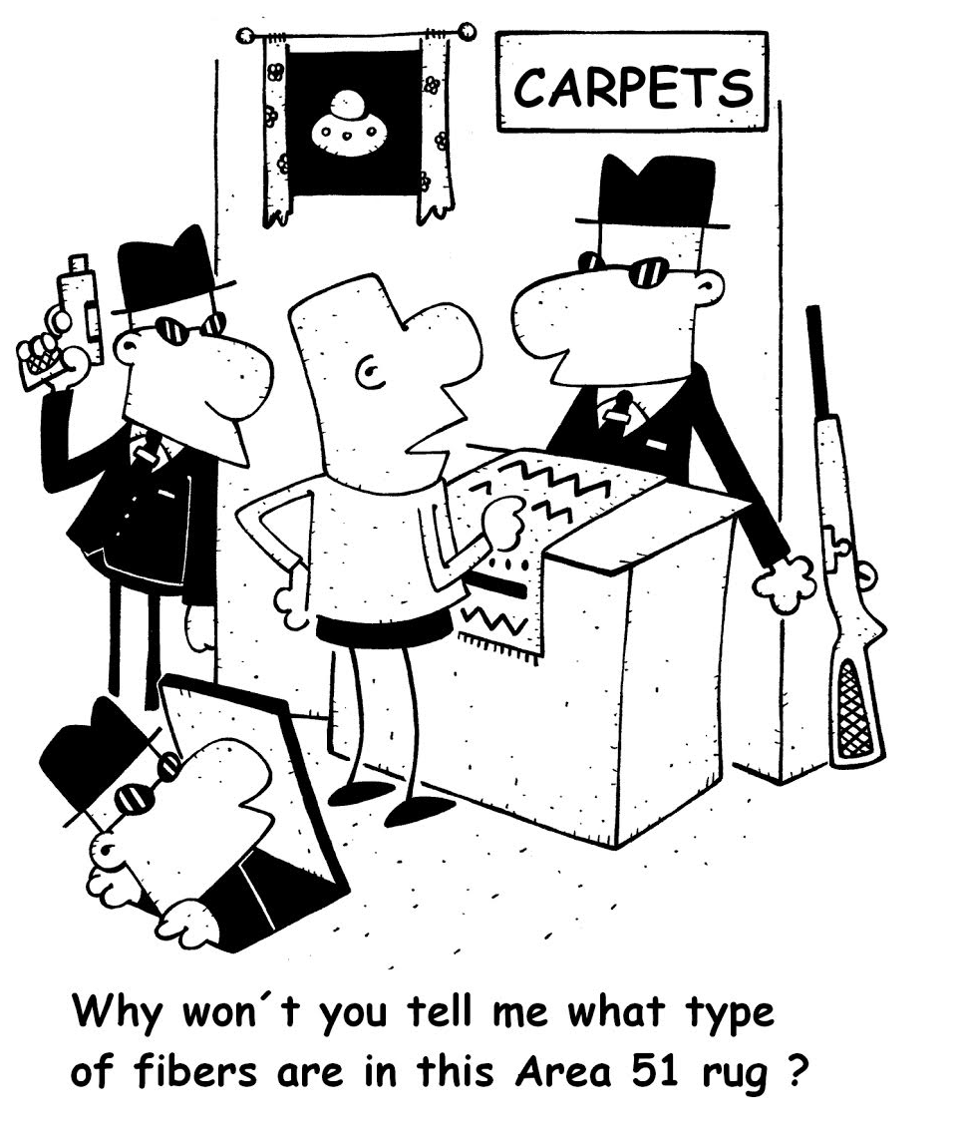Steampunk Christmas
In the
steam-driven society
at Christmas

children wish for coal
in their stockings.

—David Clink

Star*Line 18 Fall 2019

