The Day the Animals Turned to Sand

By TYLER HAGEMANN

“Why do you wish that?” her parents ask.

The Girl who Loved Birds

By CLARA BLACKWOOD

T

“I wish the animals had been made of glass!” a child says.
“Because, then we might have known how easily they
could break.”

he day the animals turned to sand
T
we ran our hands through their coarse remains.
Leashes lay limp, collars empty. It was the worst day of our lives. God is angry, some said.
Science will reverse it, others argued.
The animals did not deserve this, and yet, every non-human species had crumbled, the Earth littered with piles of sand,
dry-dead mounds scattered by breeze and breath.
We dared not acknowledge the elephant in the room: that without animals many people would not survive. We grew restless. The soles of our feet were burning. And a child suggested the perfect memorial—
In every village and town we became sand collectors,
scooping it by the handful, hoisting bags onto trucks, those not farming joining in the effort, color returning to their faces, straightness to their spines, they chatted and hugged and some even laughed,
the world unified in twilight, the approaching darkness.
Scientists say they will be able to feed us all,
but we were artists, then, working through the night. At last we saw them, glimmering towers of glass, story upon story of death made beautiful.
Inside, life-sized sculptures blown from the sand of the animals that had once roamed there.
Our knees hit the ground. Nobody spoke— somehow words felt like a violation.
A child asks, “What if a bird flies into it?”
Her mother replies, “Sweetheart, there are no birds.”

Tyler Hagemann is a writer and psychology student based in Toronto. He enjoys thinking about the future, even if, on occa- sion, it drives him mad. He is an optimist at heart. ■
he girl who loved birds
loved to play in pavement cracks searching for momentary flowers,
but she could not hide her wings. Others picked on her, ruthlessly, until she became plucked
bare as chicken flesh
before the great, boiling cauldron of the world.

Clara Blackwood is a poet, artist, and tarot reader based in To- ronto. She is the author of two poetry books, Subway Medusa (2007) and Forecast (2014), with Guernica Editions. Her work has appeared in Canadian and international journals. She is currently at work on a third collection of poetry. ■

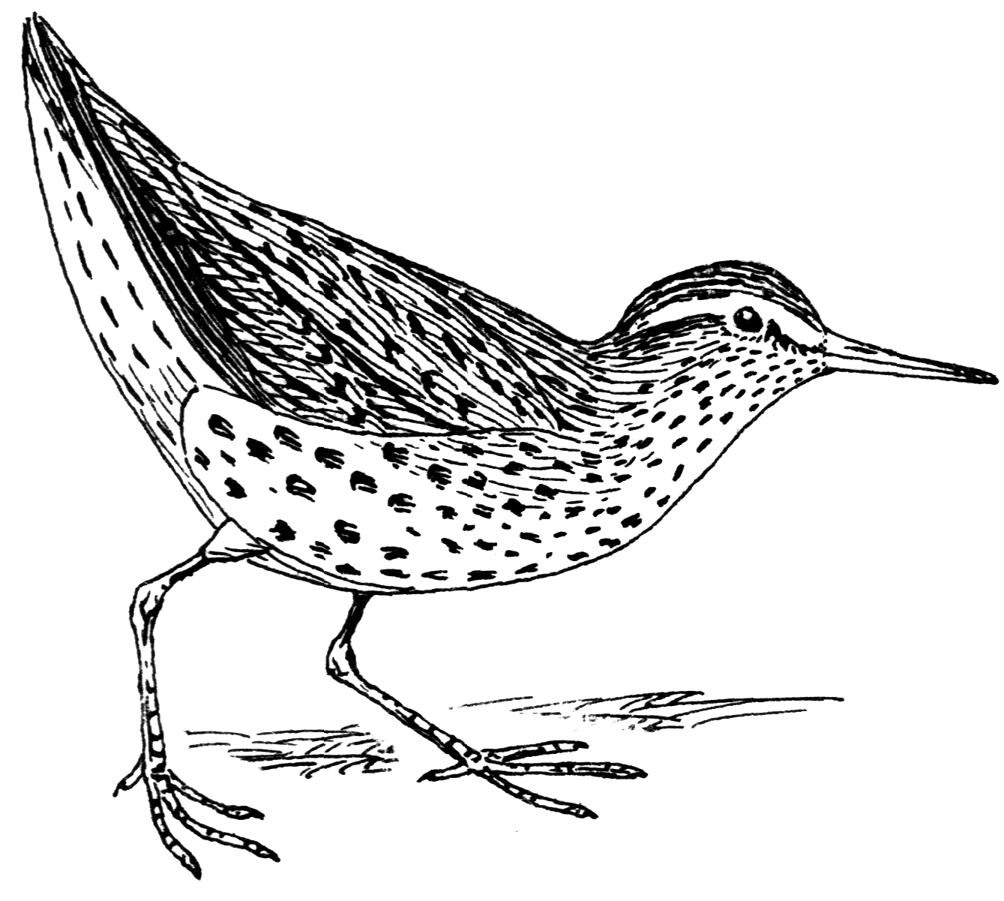
Clipart: DUMIELAUXEPICES.NET

Issue #3 Spring 2019 Page 80

